ECOR 1051

**Project Report**

Team 85 Project report

Submitted by

**[TEAM 85]**

[Adam Koziak 101140761]

[Nguyen Gia Hieu Tu, 101163887]

[Joey Murphy, 101145740]

[Henry Lin, 101162364]

Date: March 13, 2020

**Carleton University,**

**Faculty of Engineering and Design**

**1 Contents**

2 The Problem Statement................................................................................................... 2

3 The Project Goal………………………………………………………………………………....3

4 The Project Design……………………………………………………………………………....4

5 The Project Process……………………………………………………………………………. 4

6 Team Contributions………………………………………………………………………………5

7 References………………………………………………………………………………………..5

# 

# 

# 

# 

# 

# 

# **2** **The Problem Statement:**

There are many formats of an image on a computer. The two most common formats are png and jpg. Portable Network Graphics or png is a graphic file format that supports lossless data compression. While jpg images use lossy compression, this technique is used to reduce the data size of the file. Most of the time, users want to make the image look better, the easiest way is changing filters of the picture.

Figure 1: Two most common format of image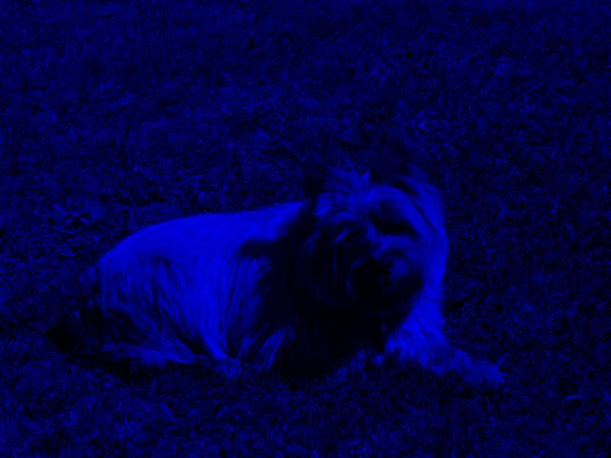

A jpg image with blue filter

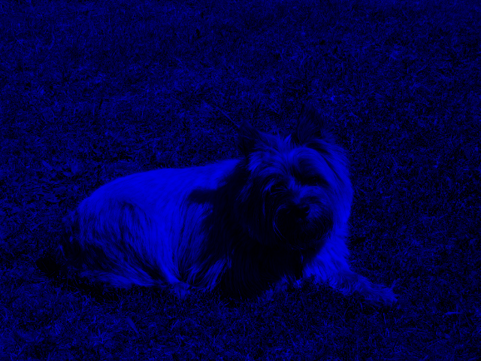

A png image with blue filter

# **3** **The Project Goal**

The goal of the project is to provide a lightweight, user friendly image editing software. It will be able to apply basic filters to an image. While using the program, an image can be chosen from a selection of different images to be altered and edited by the program in a variety of different ways, however the user would like to change it, within the boundaries of the program. It provides a simple, easy to follow interface/menu that any user can interact with to perform the task that they desire.

**4** **The Project Design**

The image editing software is based off of the Pillow and CIMPL image editing libraries. The first version of the program runs on a basic command line GUI, allowing it to be as lightweight as possible while still allowing full user control. The program loops through two nested menus, allowing the user to import an image using file I/O, and then choose from a dynamic selection of filters which will be applied to the chosen image. The program’s simplicity does not prevent easy expansion, as implementing a new filter is as simple as defining the method, adding it to the filter selection loop, and appending the filter list.

# **5** **The Project Process**

The project will be split up into three milestones, each building upon the knowledge and progress obtained in the previous. In this way, the project is developed in increments that allow each new section of code to be tested thoroughly.

Milestone 1 consists of mainly establishing the team and obtaining the knowledge required to continue in the project.

The second milestone comprises the bulk of the coding, namely the filters. Due to the large number of discrete filters, individual tasks will be delegated among each of the team members to optimize the workload for efficiency and to avoid conflicts with individual coding styles and preferences. For the final product, a modular approach will be used to combine each team member’s work into one complete program.

Over the course of the project, several code reviews will be performed to ensure that all code meets prescribed standards as well as to provide constructive feedback for individual improvement.

The final task will involve unifying all of the individual filter modules through a main script and interactive user interface.

# **6** **Team Contributions**

Project Statement : Nguyen Gia Hieu Tu

Project Goal : Joey Murphy

Project Design : Adam Koziak

Project Process: Henry Lin

# **7** **References**

A Graphical User Interface (GUI) is

[1] ECOR1051 Winter 2020, 'blue_image.png', 2020. [Online]. Available: culearn.carleton.ca [ECOR1051 Winter 2020]. [Accessed: 12-3-2020].

[1] ECOR1051 Winter 2020, 'blue_image.jpg', 2020. [Online]. Available: culearn.carleton.ca [ECOR1051 Winter 2020]. [Accessed: 12-3-2020].